How to log into ClassLink to access Programs and Textbooks

Here are step by step directions on how to access programs and textbooks through ClassLink for students.
Checked out District Device:
Select the ClassLink Icon and proceed with the log in directions below.
Using your own device: Use our District ClassLink URL and proceed with log in directions below
https://launchpad.classlink.com/citrus

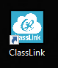

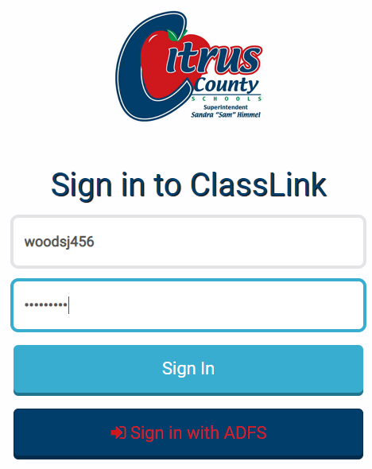
If you do not have your student number, you may locate it on Skyward or from your child’s teacher.

This is where students will log in with their last name first initial and the last three digits of their student id number (example: woodsj456). Then for their password, they will use the letters St followed by their full student number (St123456). (this is case sensitive)

Once in ClassLink, they will select the desired Tile for that program.
